Lab Assignment 1-3 Exploring File Systems - Linux+ and LPIC-1 Answers

- At the command prompt, type pwd. What is your current working directory? Show results.
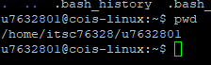
- At the command prompt, type cd.. then type pwd to view the current working directory. Did your current working directory change? Show results.
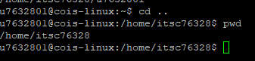
pwd
- At the command prompt, type cd / then type pwd to view the current working directory. Did your current working directory change? Show results. Did you specify a relative or absolute pathname when you used the cd / command?
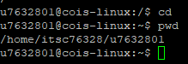
- At the command prompt, type cd etc. Enter pwd and show results of both commands.
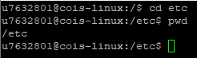
- At the command prompt, type cd ~ then type pwd to view and show the results. Did you use a relative or absolute pathname when you used the cd ~ command?
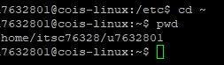
- At the command prompt, type cd /etc. Verify that you are in the /etc directory by typing pwd at the command prompt and show results.
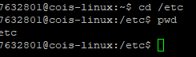
- At the command prompt, enter ls and show results.
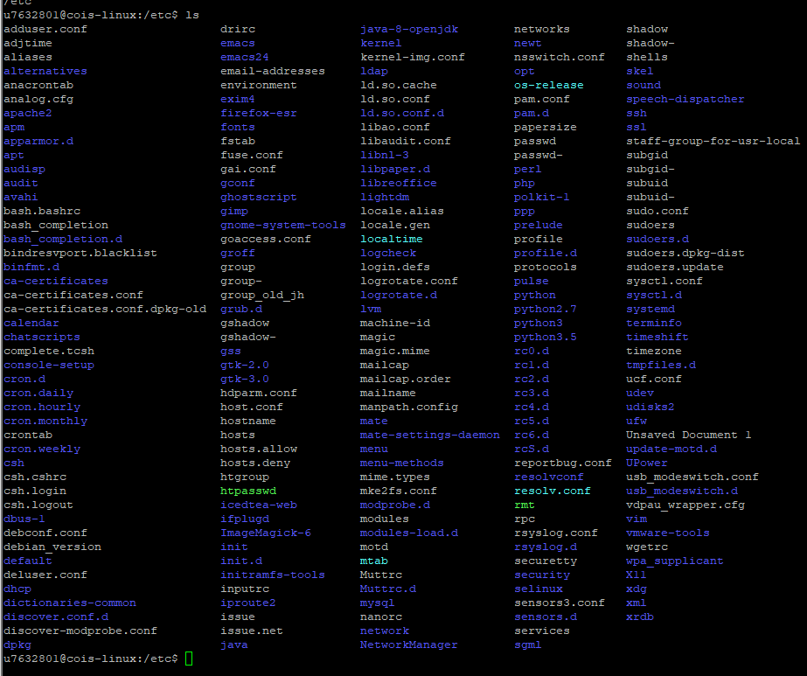
- At the command prompt, enter ls | more. Notice the highlighted --More--prompt at the bottom of the screen. Press Enter. Press Enter again. Press Enter once more. Notice that each time you press Enter, you advance one line further into the file. Now, press the spacebar. Press the spacebar again. Notice that with each press of the spacebar, you advance one full page into the displayed directory contents. Show results of the first and final step. Press the q key to quit the more command and return to an empty command prompt.
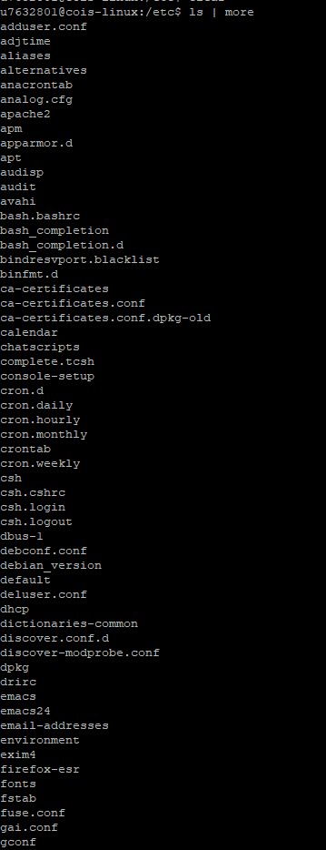

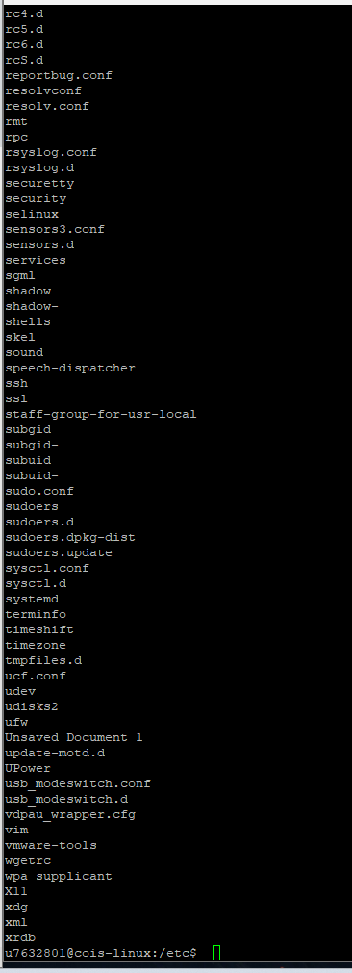
- At the command prompt, type ls | less. Show results. Notice the : at the bottom of the screen. Press Enter. Press Enter again. Press Enter once more. Notice that each time you press Enter, you advance one line further into the file. Now press the spacebar. Press the spacebar again. Notice that with each press of the spacebar, you advance one full page into the displayed directory contents. Press the ↑ (up arrow) key. Press ↑ again. Press ↑ once more. Notice that each time you press the ↑ key, you go up one line in the file display toward the beginning of the file. Now, press the ↓ (down arrow) key. Press ↓ again. Press ↓ once more. Notice that each time you press the ↓ key, you move forward into the file display. Show results of your final screen. Press the q key to quit the less command and return to a shell command prompt.
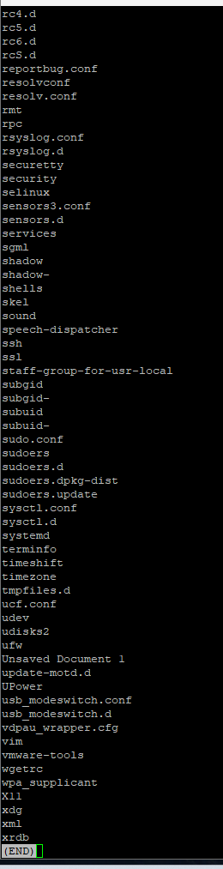
- At the command prompt, type cd then at the command prompt, type pwd . What is your current working directory? At the command prompt, type ls and show results
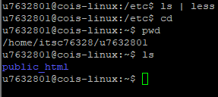
- At the command prompt, type ls /etc and show results. Notice that you were able to list the contents of another directory by giving the absolute name of it as an argument to the ls command without leaving the directory in which you are currently located.
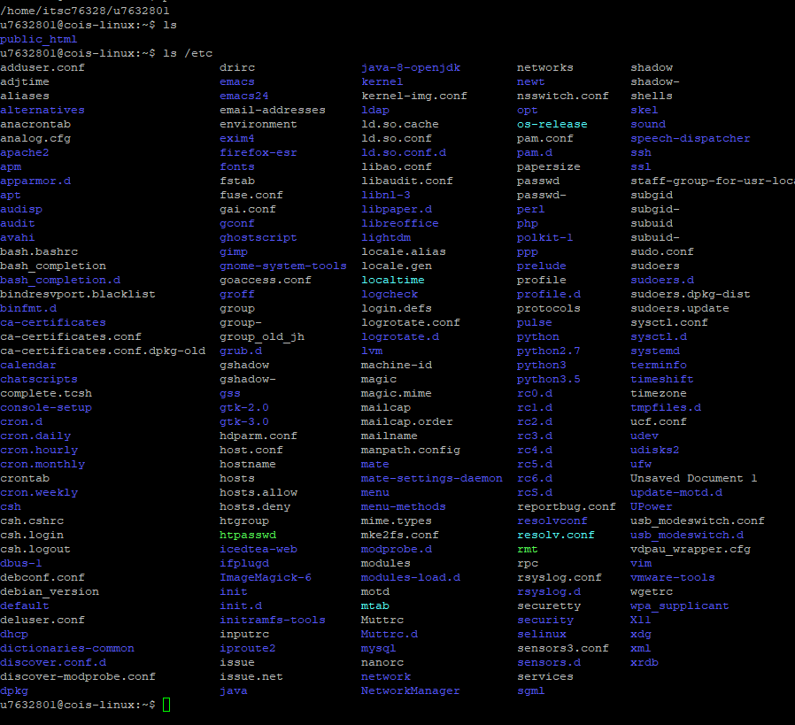
- At the command prompt, type ls /etc/skel. Did you see a listing of any files? No. At the command prompt, type ls -a /etc/skel and show results. What is special about these files? What does . and .. in the results represent?
. (dot): This represents the current directory. When you see '.' in a listing, it refers to the directory you are currently in.

.. (dot-dot): This represents the parent directory. It refers to the directory immediately above the current one in the directory hierarchy.
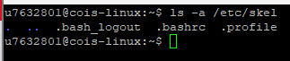
- At the command prompt, type ls -aF /etc/skel and show results. Which file types are available in the /etc/skel directory?

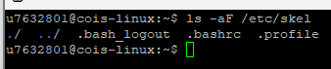
- At the command prompt, type ls /bin. Did you see a listing of any files? At the command prompt, type ls -F /bin/* and show results. What file types are present in the /bin directory?
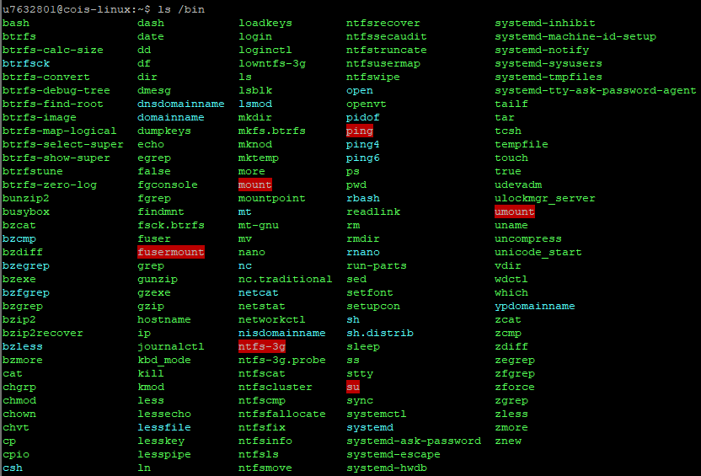

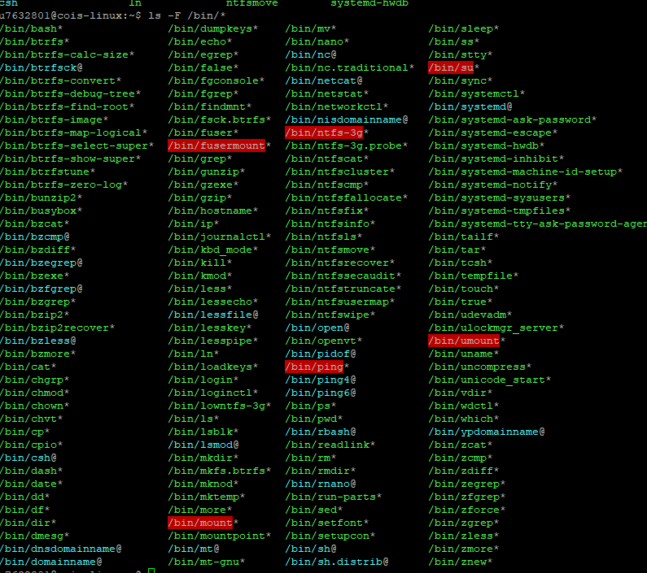
- At the command prompt, type ls /lib and show results. Next, type ls –l /lib and show resuls. What additional information is available on the screen? What types of files are available in the /lib directory?
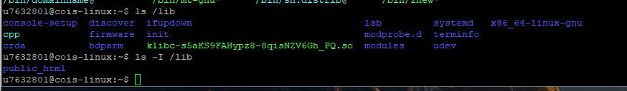
- At the command prompt, type file /etc and show results. What kind of file is etc?
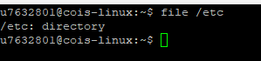
- At the command prompt, type file /etc/services and show results. What type of file is /etc/services.
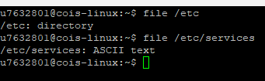
- At the command prompt, type cat /etc/hosts to view the contents of the file hosts, which reside in the directory /etc. Next, type cat –n /etc/hosts. How many lines does the file have? At the command prompt, type tac /etc/hosts to view the same file in reverse order. Show the results of all commands.
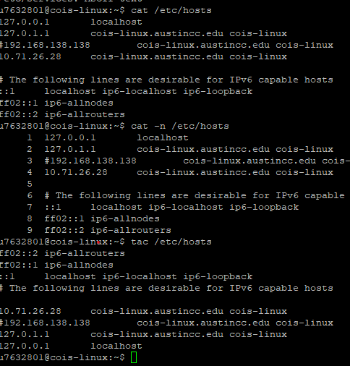
- To see the contents of the same file in octal format instead of ASCII text, type od /etc/ hosts at the command prompt and show results
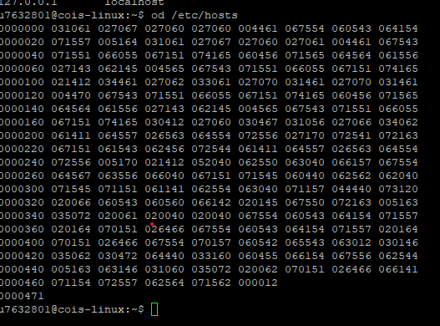
- At the command prompt, type cat /etc/services. What is the last line of output?
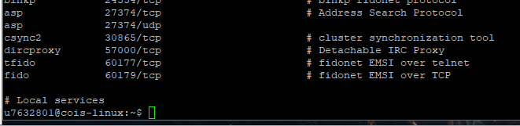
- At the command prompt, type head /etc/services and show results. How many lines are displayed, which ones are they?
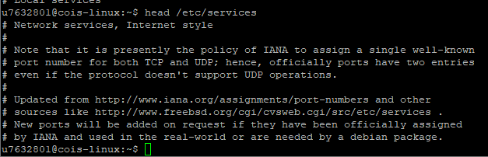
- At the command prompt, type head -5 /etc/services.. How many lines are displayed and why? Next, type head -3 /etc/services and show results. How many lines are displayed and why?
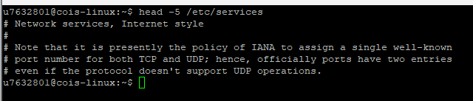

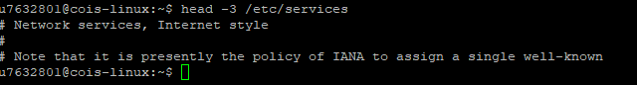

- At the command prompt, type tail /etc/services. What is displayed on the screen? How many lines are displayed; which ones are they? Next, at the command prompt, type tail -5 /etc/services and show results. How many lines are displayed and why?
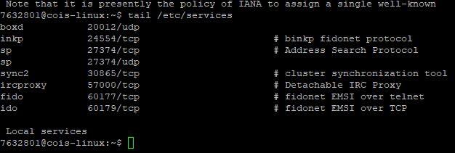

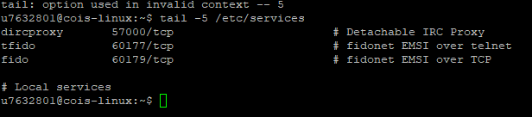
- At the command prompt, type file /bin/mount and show results. What type of file is it?

